**NAMES: UWIMANA ANGELIQUE**

**STUDENT ID:28868**

**DBMS ASSIGNMENT 1 group F**

**ABOUT FUNCTIONS**

# STRING FUNCTIONS

## Concatenate first and last name as full_name.

select concat(first_name,' ', last_name ) as full_name from employee;

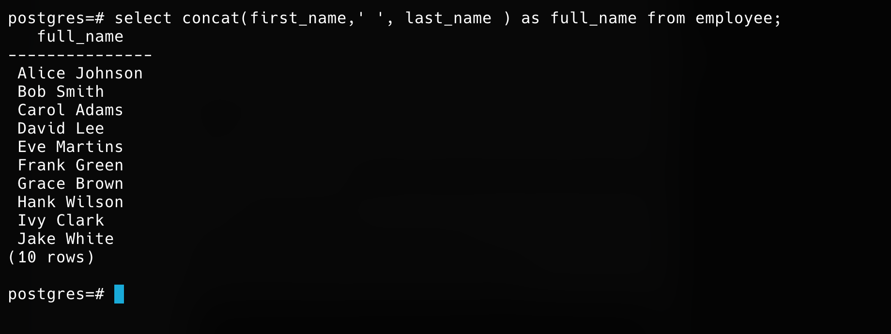

## Convert all employee names to lowercase

select lower(concat(first_name,' ', last_name)) AS full_name from employee;

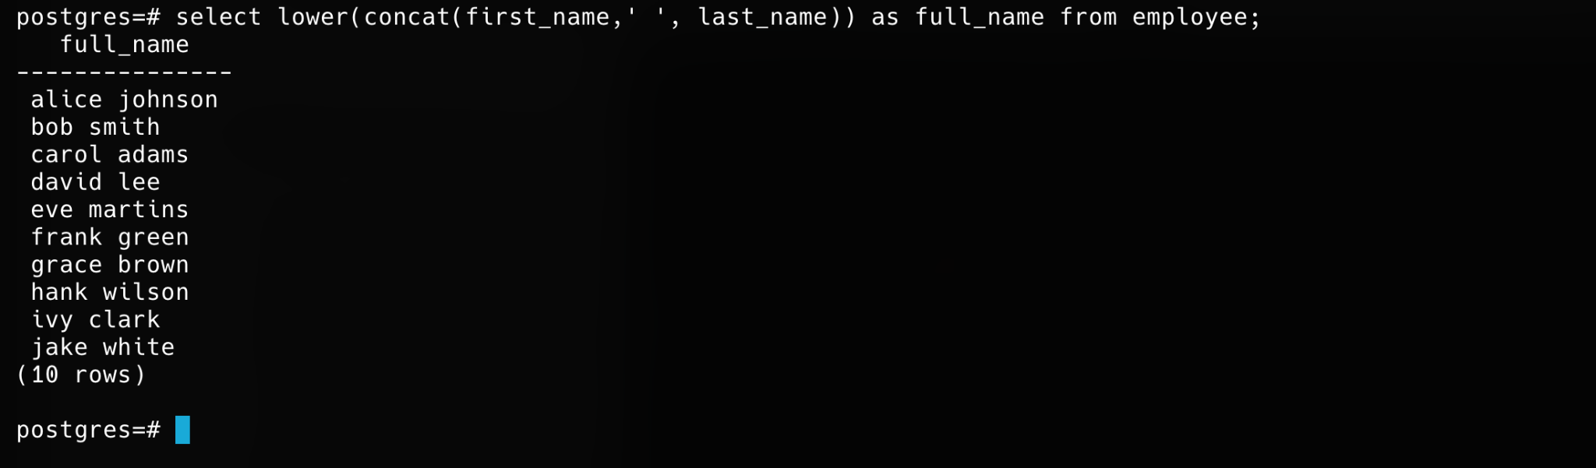

## Extract first 3 letters of the employee's first name

select substring(first_name, 1,3) from employee;

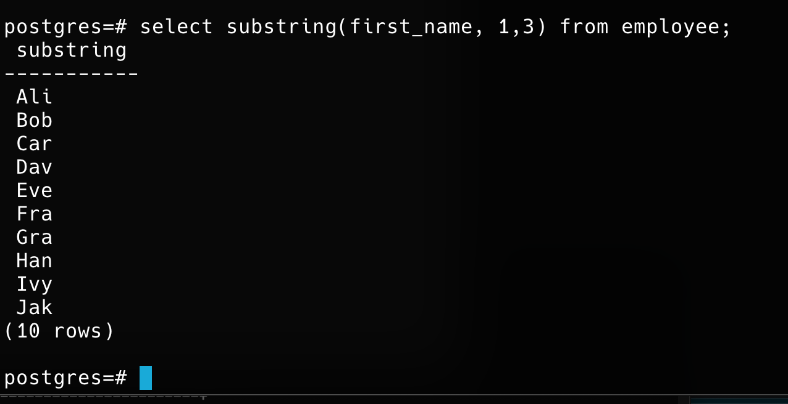

## Replace '@company.com' in email with '@org.com'

select replace(email, '@company.com', '@org.com') from employee;

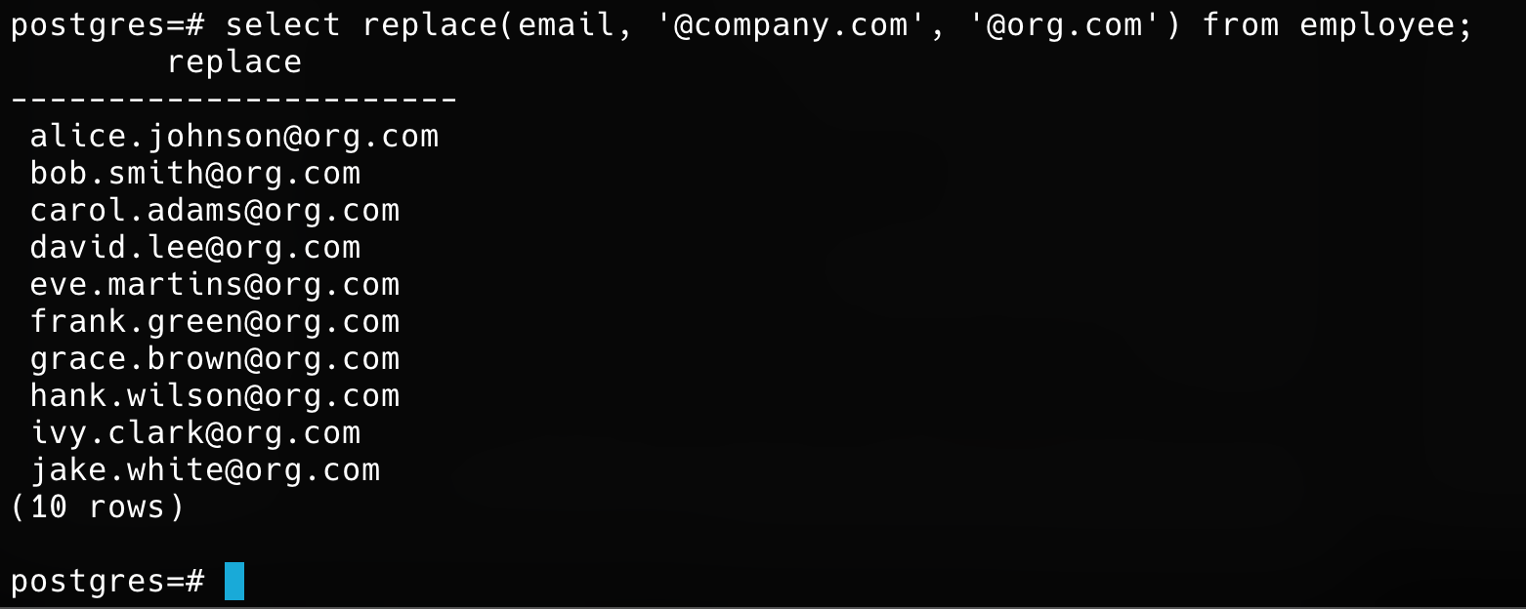

## Trim spaces from a padded string.

select trim( first_name) from employee;

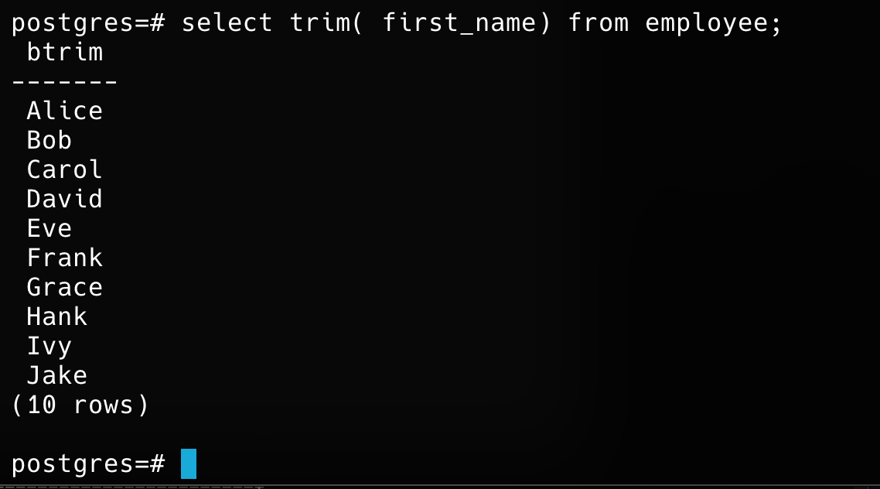

## Count characters in an employee’s full name

select length(concat(first_name,'',last_name)) from employee;

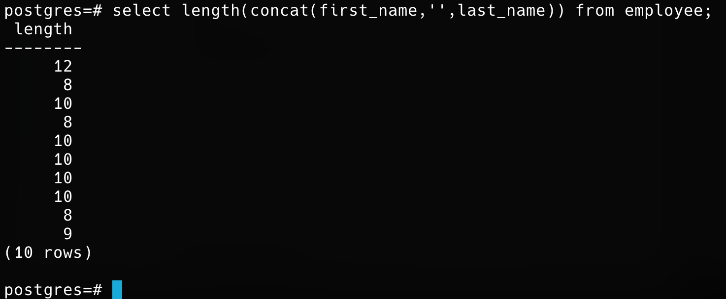

## Find position of '@' in email using INSTR()/CHARINDEX().

select position( '@' in email) as postion from employee;

## Add ‘Mr.’ or ‘Ms.’ before names based on gender (assume gender exists).

select employee_id, case when gender = 'm' then 'mr. ' || first_name || ' ' || last_name when gender = 'f' then 'ms. ' || first_name || ' ' || last_name else first_name || ' ' || last_name end as full_name_with_title, email, hire_date, salary, department_id from employee;



## Format project names to uppercase.

select upper(project_name) from projects;

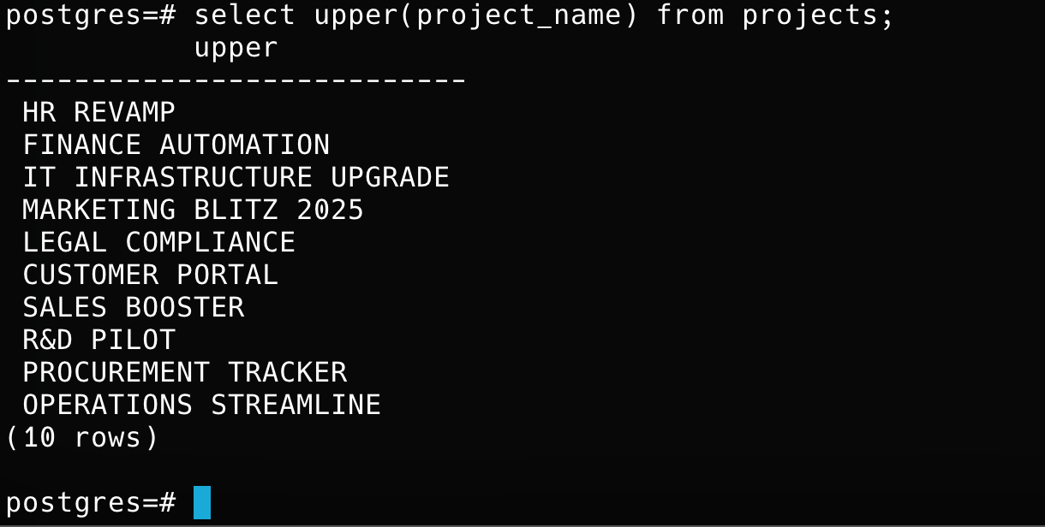

## Remove any dashes from project names.

select project_name, replace(project_name,'-','') as cleaned_project_name from projects;

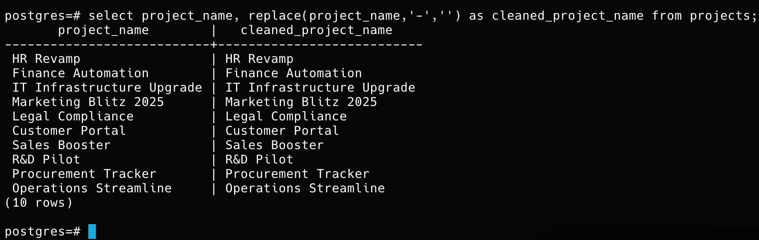

## Create a label like “Emp: John Doe (HR)”

select concat(‘Eng: ', first_name,' ',last_name,'(IT)') as full_name from employee;

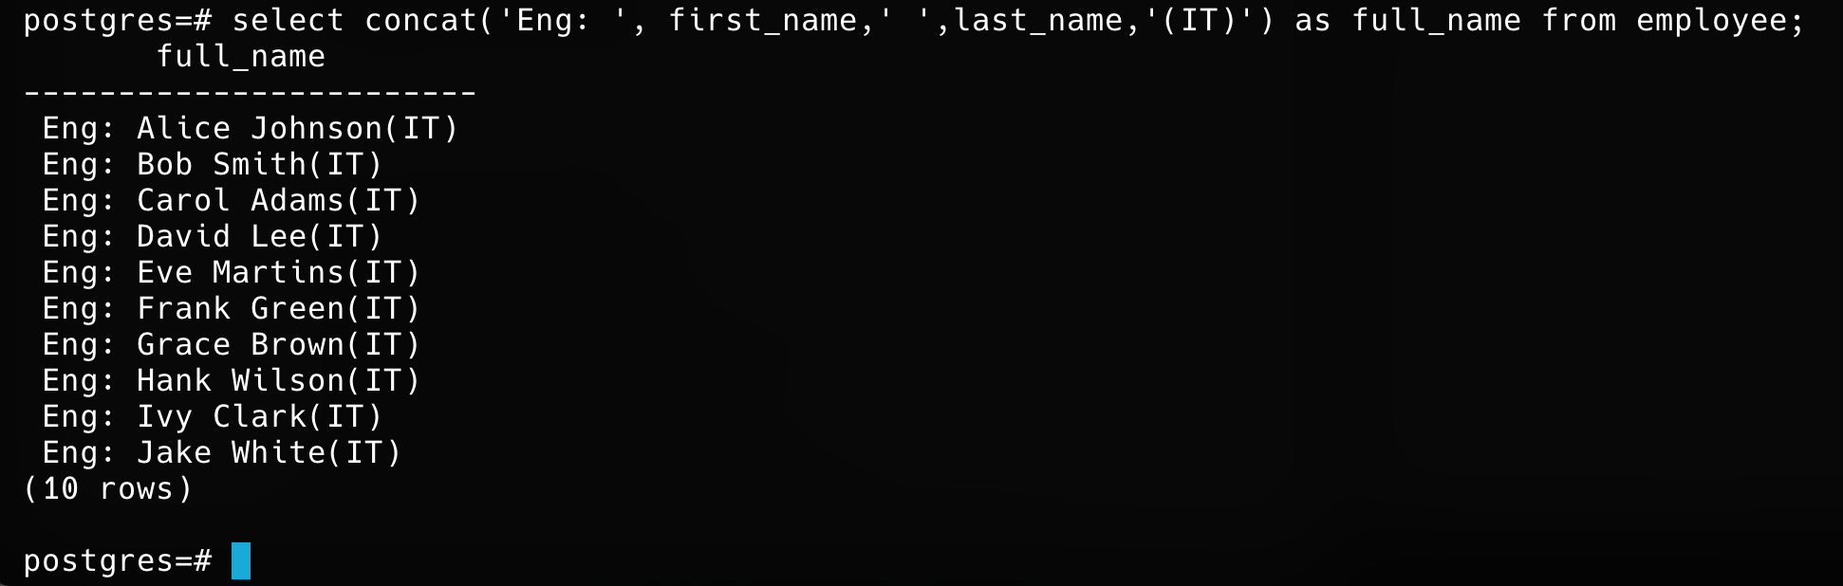

## Check email length for each employees

select first_name, email, length(email) from employee;

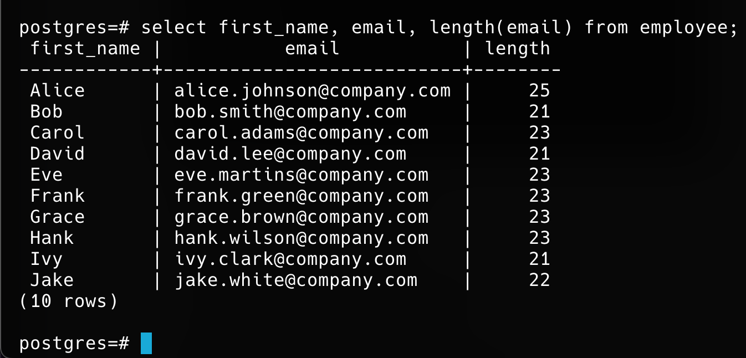

## Extract last name only from email (before @).

select split_part(split_part(email, '@', 1), '.', 2) as last_name from employee;

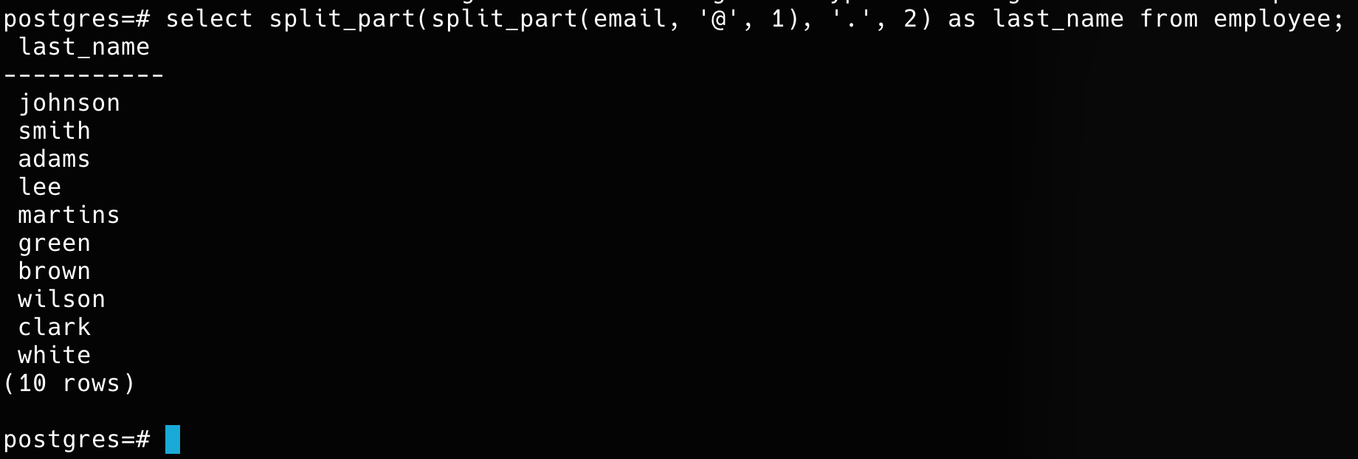

## Format: “LASTNAME, Firstname” using UPPER and CONCAT

select concat(upper(last_name),' ',first_name) from employee;

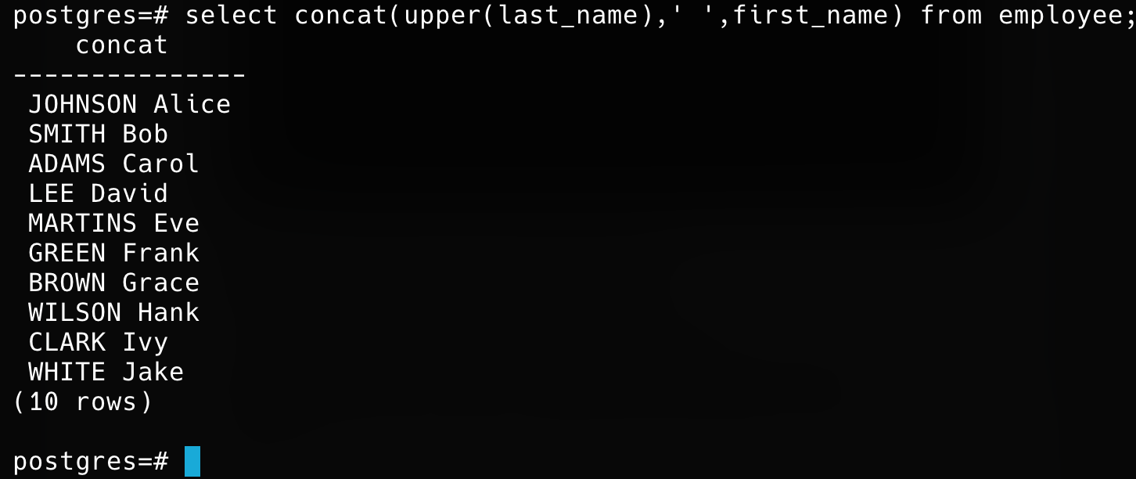

## Add “(Active)” next to employee names who have current projects.

select concat(e.first_name, ' ', e.last_name, case when exists (select 1 from employee_projects ep join projects p on ep.project_id = p.project_id where ep.employee_id = e.employee_id and p.end_date is null) then ' (Active)' else '' end) as employee_name from employee e;

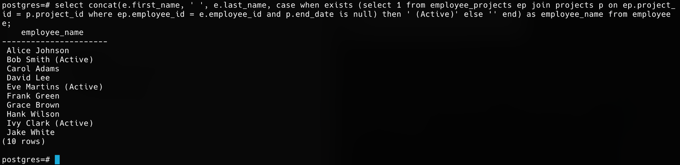

# NUMERIC FUNCTIONS

## Round salary to the nearest whole number

select first_name, last_name, salary, round(salary) as rounded_salary from employee;

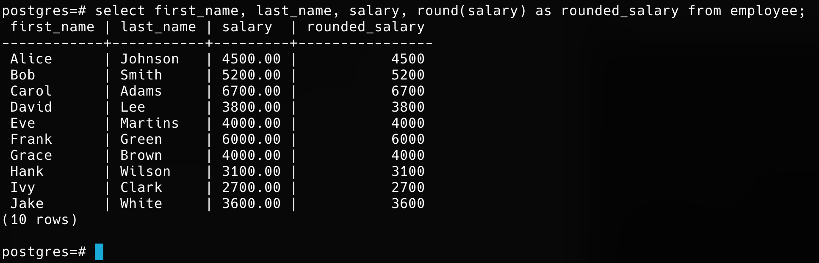

## Show only even salaries using MOD.

select * from employee where mod(salary, 2)=0;

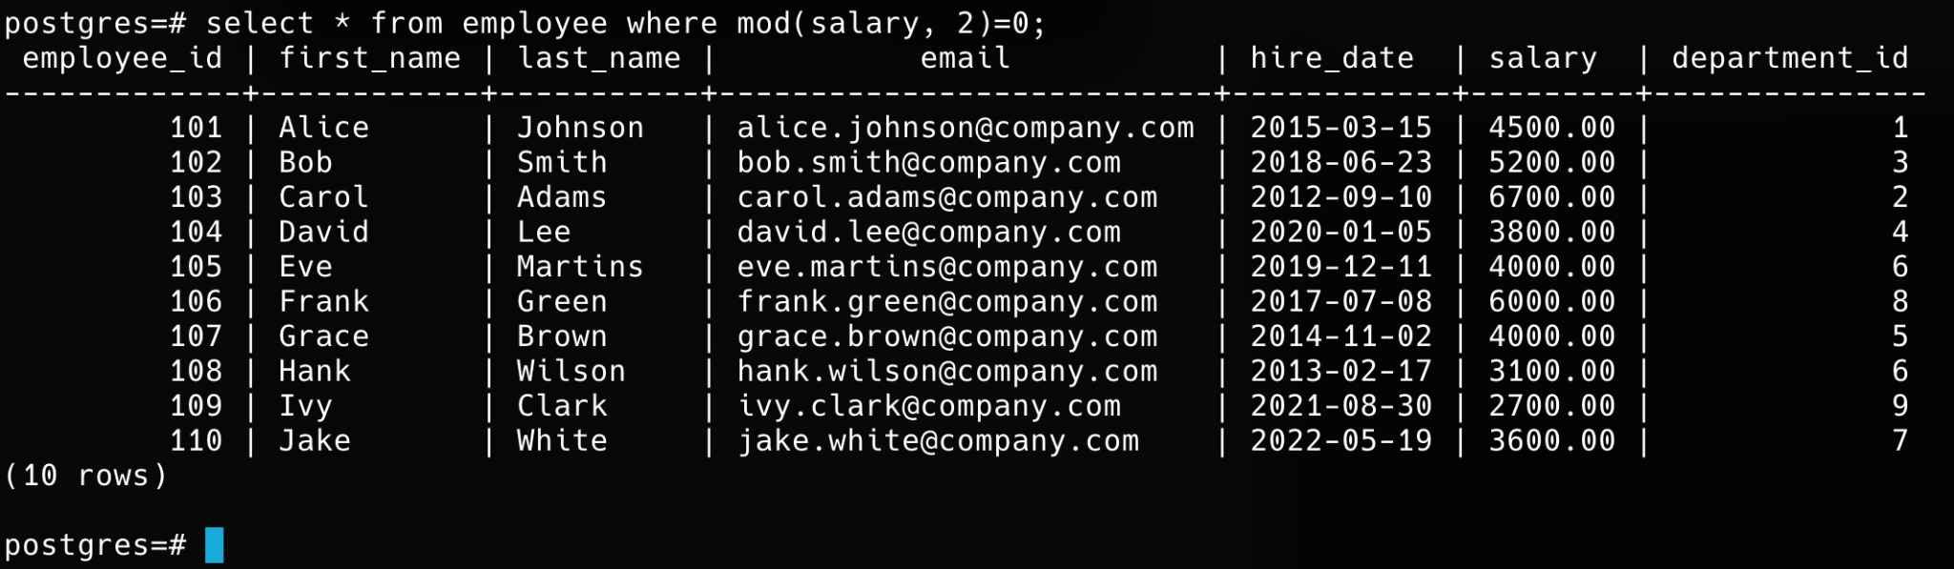

## Show difference between two project end/start dates using DATEDIFF (i.e DATEDIFF not supported in postgress)

select project_name, (coalesce(end_date::date, '2025-08-04'::date) - start_date::date) as days_difference from projects;

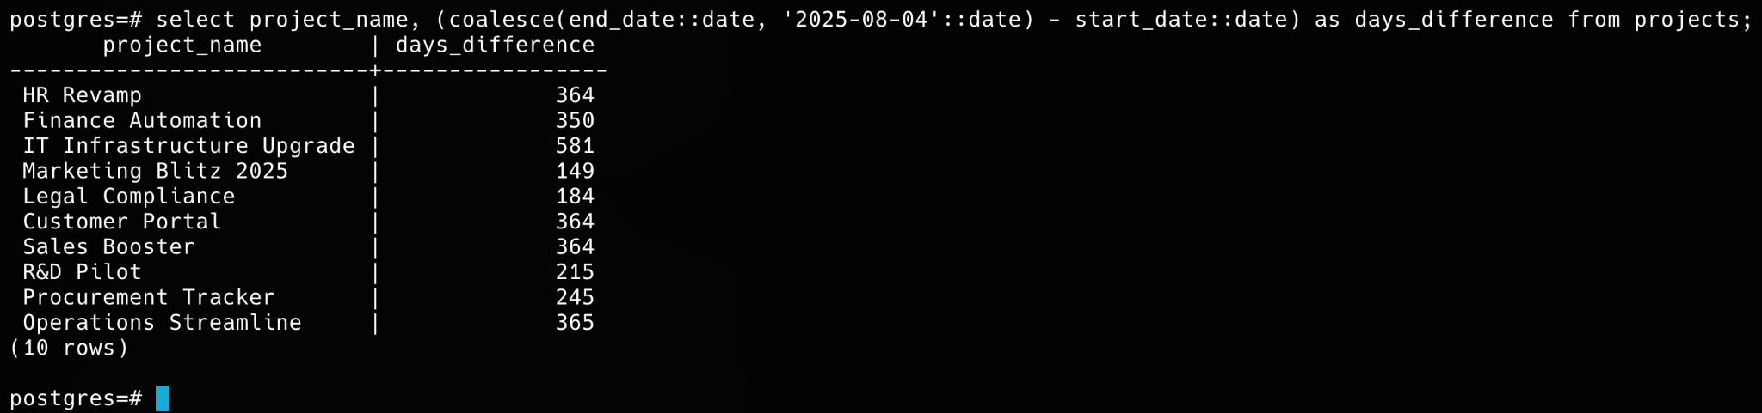

## Show absolute difference in salaries between two employees.

select concat(e1.first_name, ' ', e1.last_name) as employee1, concat(e2.first_name, ' ', e2.last_name) as employee2, abs(e1.salary - e2.salary) as salary_difference from employee e1 join employee e2 on e1.employee_id < e2.employee_id;



## Raise salary by 10% using POWER.

select salary, salary * power(1.10, 3) as salary_after_3_raises from employee;

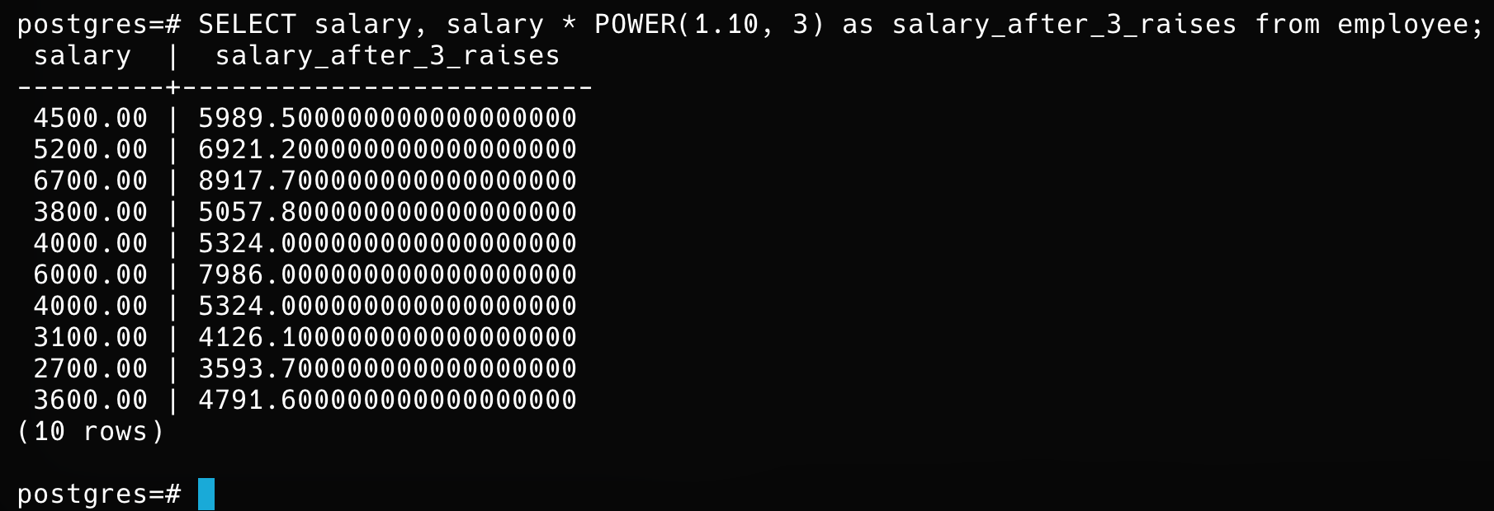

## Generate a random number for testing IDs.

select floor(random() * 1000 + 1)::integer as test_id;

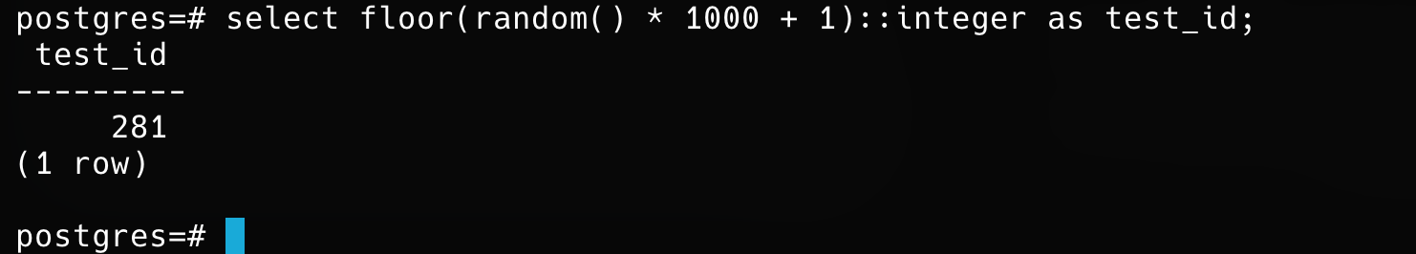

## Use CEIL and FLOOR on a floating salary

select concat(first_name, ' ', last_name) as employee_name, salary, floor(salary) as floor_salary, ceil(salary) as ceil_salary from employee;

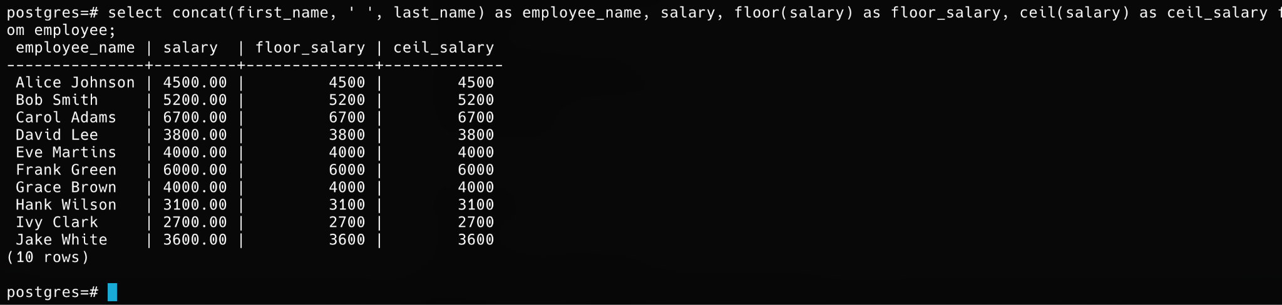

## Use LENGTH() on phone numbers (assume column exists).

select concat(first_name, ' ', last_name) as employee_name, phone_number, length(phone_number) as phone_number_length from employee;

## Categorize salary: High/Medium/Low using CASE.

select concat(first_name, ' ', last_name) as employee_name, salary, case when salary >= 5000 then 'high' when salary >= 3000 then 'medium' else 'low' end as salary_category from employee;

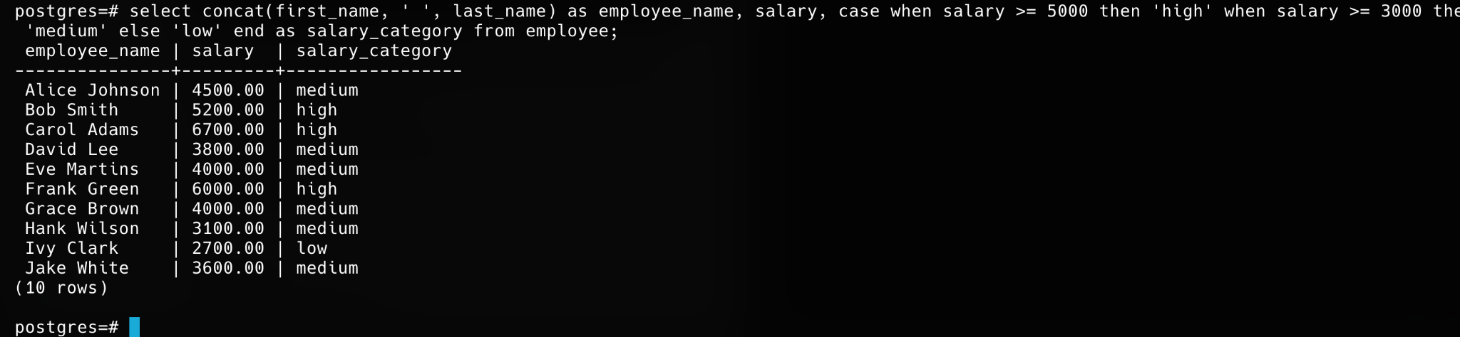

## Count digits in salary amount.

select salary, length(replace(salary::text, '.', '')) as digit_count from employee;

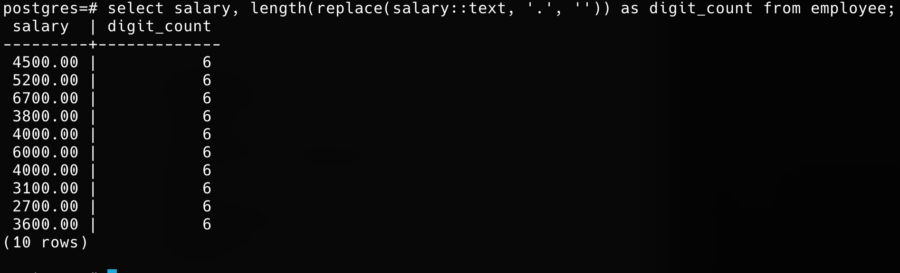

# DATE/TIME FUNCTIONS

## Show today’s date using CURRENT_DATE.

select current_date;

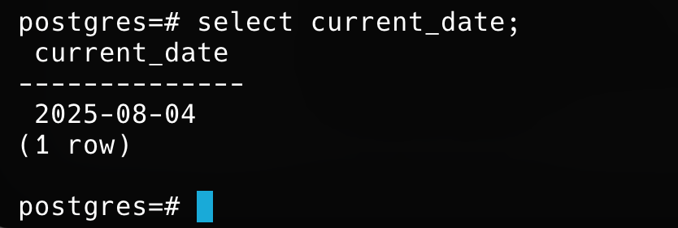

## Calculate how many days an employee has worked.

select first_name, last_name, hire_date, datediff(current_date, hire_date) as days_worked from employee;

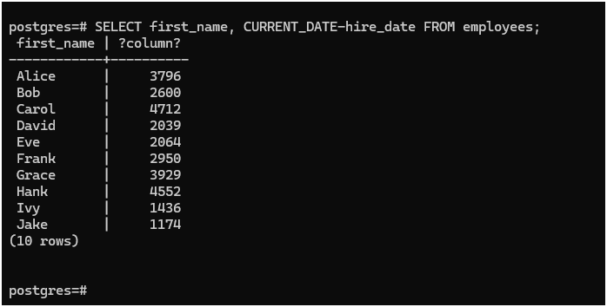

## Show employees hired in the current year.

SELECT first_name, last_name, hire_date FROM employee WHERE YEAR(hire_date) = YEAR(CURRENT_DATE);

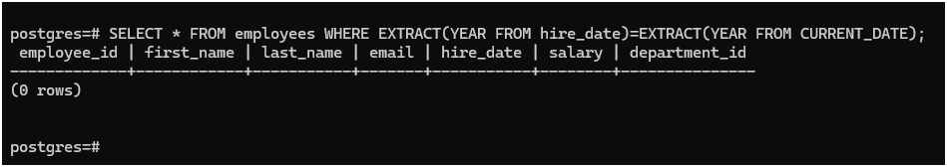

## Display current date and time using NOW().

select now() as current_datetime;

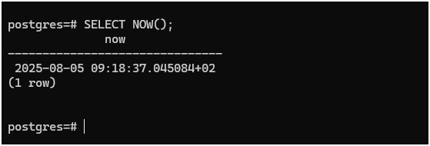

## Extract the year, month, and day from hire_date.

SELECT first_name, last_name, hire_date, YEAR(hire_date) AS hire_year, MONTH(hire_date) AS hire_month, DAY(hire_date) AS hire_day FROM employee;

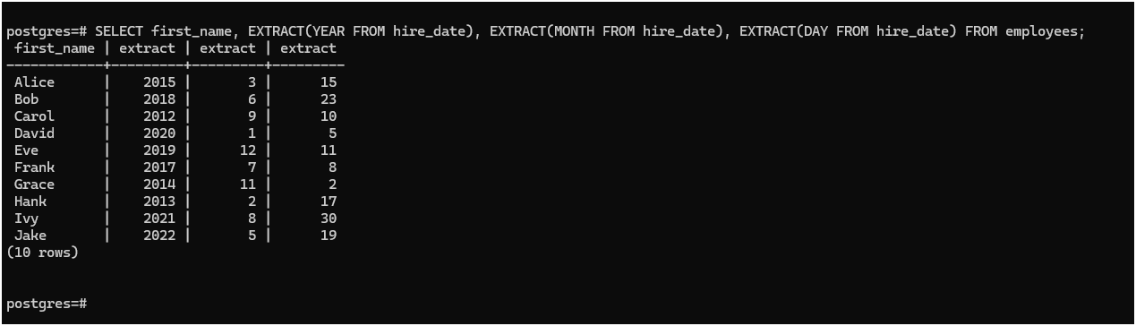

## Show employees hired before 2020.

SELECT first_name, last_name, hire_date FROM employee WHERE hire_date < '2020-01-01';

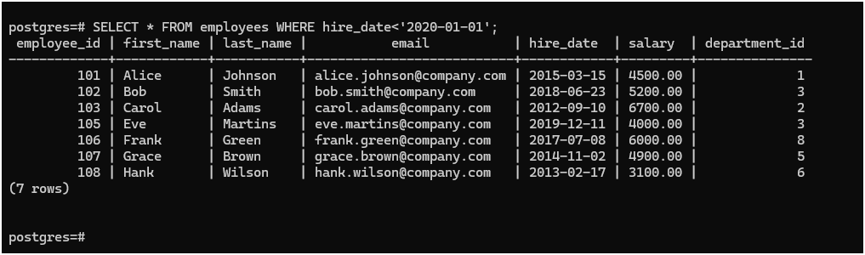

## List projects that ended in the last 30 days.

SELECT project_name, end_date FROM projects WHERE end_date BETWEEN DATE_SUB(CURRENT_DATE, INTERVAL 30 DAY) AND CURRENT_DATE;

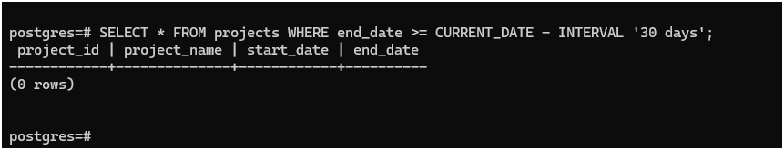

## Calculate total days between project start and end dates.

SELECT project_name, start_date, end_date, DATEDIFF(end_date, start_date) AS total_duration_days FROM projects;

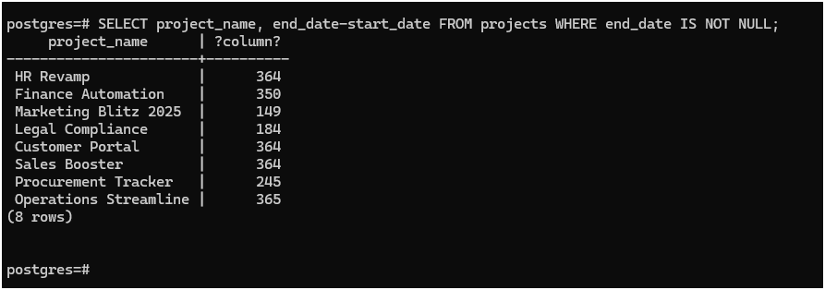

## Format date: ‘2025-07-23’ to ‘July 23, 2025’ (use CONCAT).

SELECT CONCAT( MONTHNAME('2025-07-23'), ' ', DAY('2025-07-23'), ', ', YEAR('2025-07-23') ) AS

formatted_date;

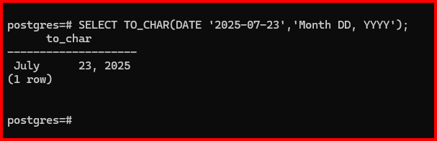

## Add a CASE: if project still active (end_date IS NULL), show ‘Ongoing’.

SELECT project_name, start_date, CASE WHEN end_date IS NULL THEN 'Ongoing' ELSE DATE_FORMAT(end_date, '%Y-%m-%d') END AS project_status_or_end_date FROM projects;

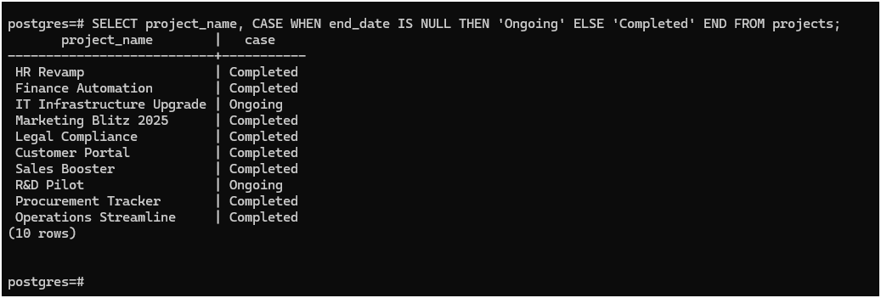

# CONDITIONAL FUNCTIONS

1. **Use CASE to label salaries.**

SELECT first_name, last_name, salary, CASE WHEN salary >= 5000 THEN 'High' WHEN salary >= 3500 THEN 'Medium' ELSE 'Low' END AS salary_label FROM employee;

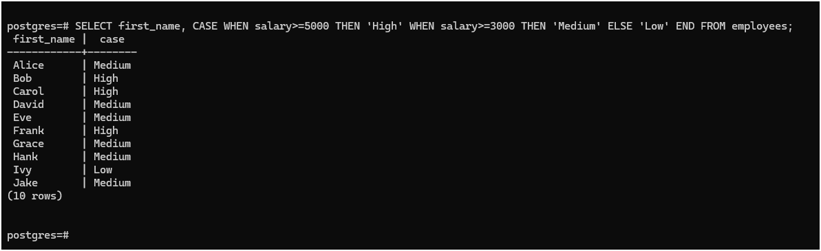

## Use COALESCE to show ‘No Email’ if email is NULL.

SELECT first_name, last_name, COALESCE(email, 'No Email') AS email_address FROM employee;

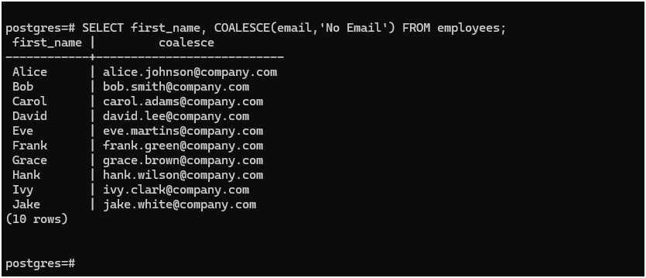

## CASE: If hire_date < 2015, mark as ‘Veteran’

SELECT first_name, last_name, hire_date, CASE WHEN hire_date < '2015-01-01' THEN 'Veteran' ELSE 'Newcomer' END AS employee_status FROM employee;

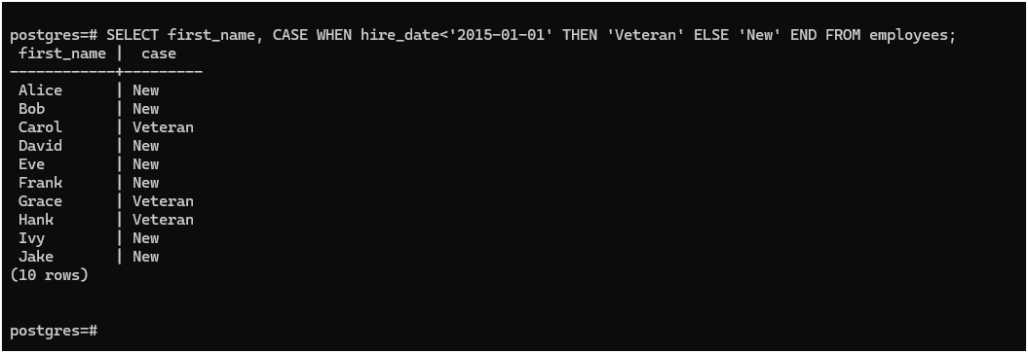

## If salary is NULL, default it to 3000 using COALESCE

SELECT first_name, last_name, COALESCE(salary, 3000) AS salary_with_default FROM employee;

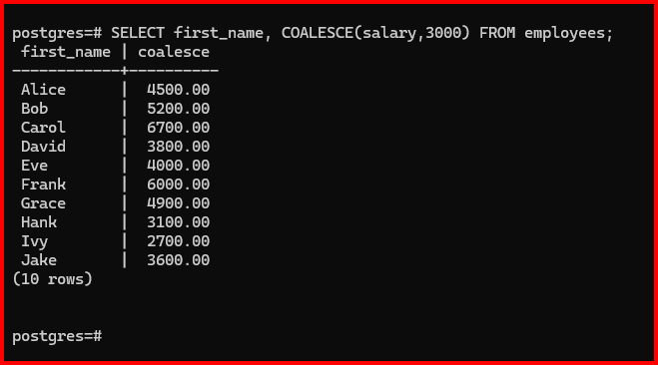

## CASE: Categorize departments (IT, HR, Other).

SELECT first_name, last_name, department, CASE WHEN department = 'IT' THEN 'IT' WHEN department

= 'HR' THEN 'HR' ELSE 'Other' END AS department_category FROM employee;

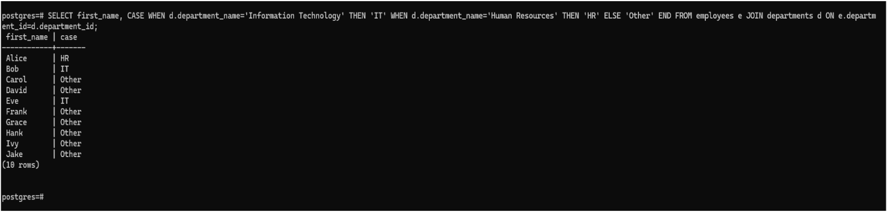

**41. CASE: If employee has no project, mark as ‘Unassigned’.**

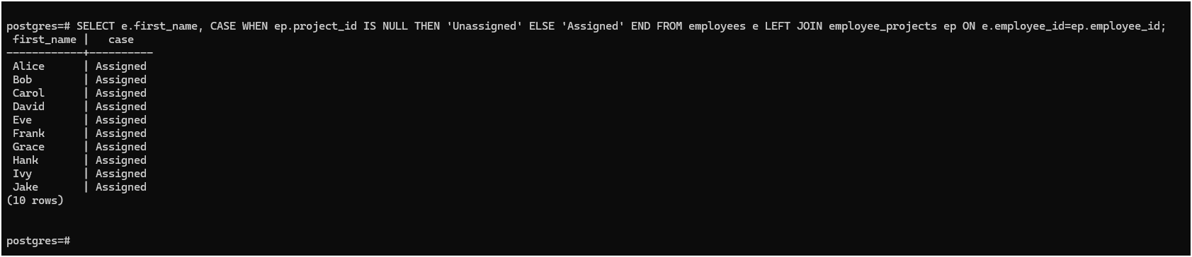

## CASE: Show tax band based on salary

SELECT first_name, last_name, salary, CASE WHEN salary >= 5000 THEN 'High Tax Band' WHEN salary >= 3500 THEN 'Mid Tax Band' WHEN salary >= 1000 THEN 'Low Tax Band' ELSE 'No Tax' END AS tax_band FROM employee;

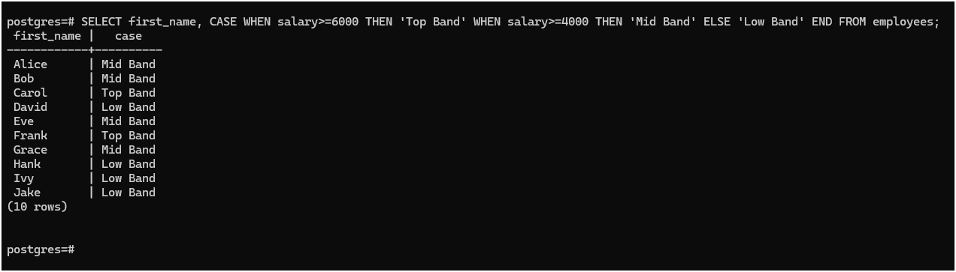

## Use nested CASE to label project duration

SELECT project_id, project_name, start_date, end_date, DATEDIFF(end_date, start_date) AS duration_days, CASE WHEN DATEDIFF(end_date, start_date) < 350 THEN 'Short' WHEN DATEDIFF(end_date, start_date) BETWEEN 350 AND 480 THEN CASE WHEN DATEDIFF(end_date, start_date) <= 90 THEN 'Medium' ELSE 'Moderately Long' END ELSE 'Long' END AS duration_label FROM projects;

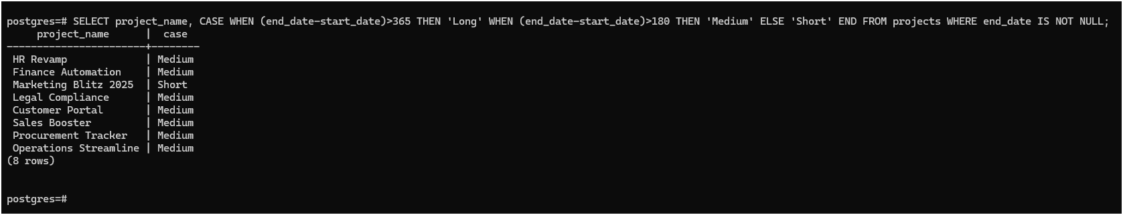

## Use CASE with MOD to show even/odd salary IDs.

SELECT employee_id, first_name, salary, CASE WHEN MOD(employee_id, 2) = 0 THEN 'Even' ELSE 'Odd' END AS id_parity FROM employee;

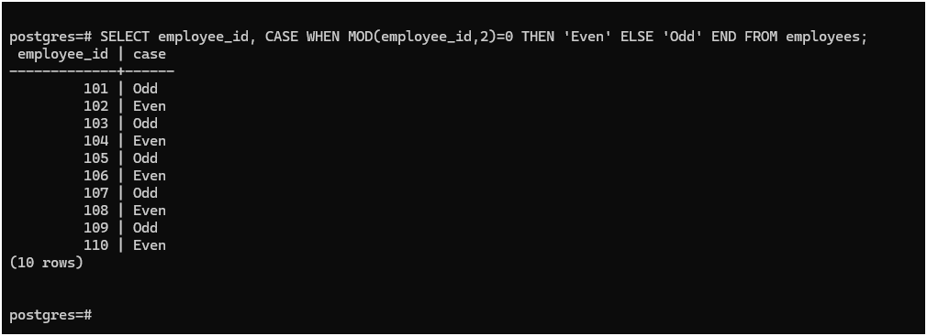

## Combine COALESCE + CONCAT for fallback names.

SELECT employee_id, CONCAT( COALESCE(first_name, 'Unknown'), ' ', COALESCE(last_name, 'Unknown') ) AS full_name FROM employee;

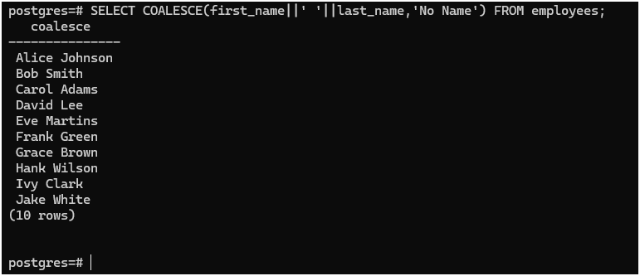

## CASE with LENGTH(): if name length > 10, label “Long Name”.

SELECT first_name, LENGTH(first_name) AS name_length, CASE WHEN LENGTH(first_name) > 10 THEN 'Long Name' ELSE 'Short Name' END AS name_label FROM employee;

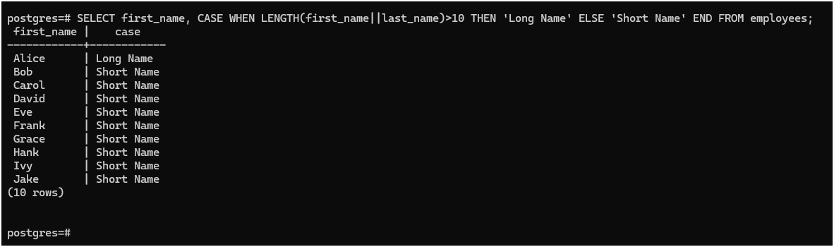

## CASE + UPPER(): if email has ‘TEST’, mark as dummy account.

SELECT email, CASE WHEN UPPER(email) LIKE '%TEST%' THEN 'Dummy Account' ELSE 'Real Account' END AS account_type FROM employee;

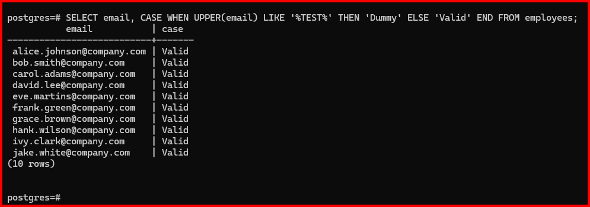

## CASE: Show seniority based on hire year (e.g., Junior/Senior)

SELECT first_name, hire_date, CASE WHEN YEAR(hire_date) <= YEAR(CURDATE()) - 10 THEN 'Senior' WHEN YEAR(hire_date) <= YEAR(CURDATE()) - 5 THEN 'Mid-Level' ELSE 'Junior' END AS seniority_level FROM employee;

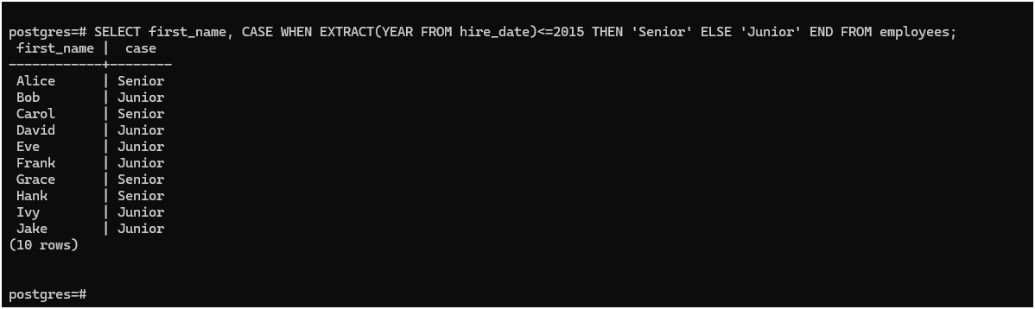

## Use CASE to determine salary increment range.

SELECT employee_id, first_name, salary, CASE WHEN salary >= 5000 THEN 'Increase by 5%' WHEN salary >= 3500 THEN 'Increase by 10%' WHEN salary >= 2000 THEN 'Increase by 15%' ELSE 'Increase by 20%' END AS increment_range FROM employee;

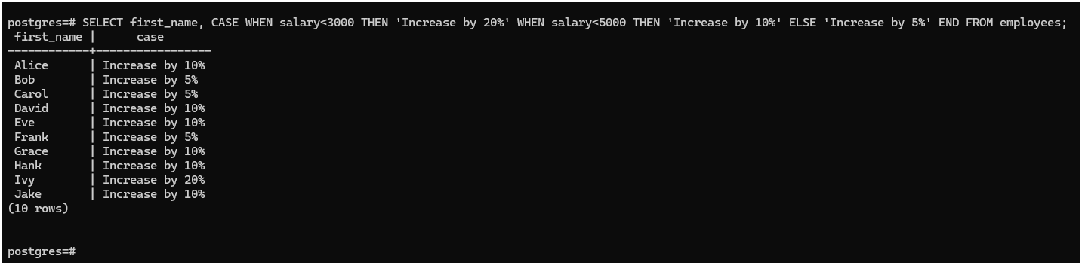

## Use CASE with CURDATE() to determine anniversary month.

SELECT employee_id, first_name, hire_date, CASE WHEN MONTH(hire_date) = MONTH(CURDATE()) THEN 'Anniversary Month' ELSE 'Not Anniversary Month' END AS anniversary_status FROM employee;

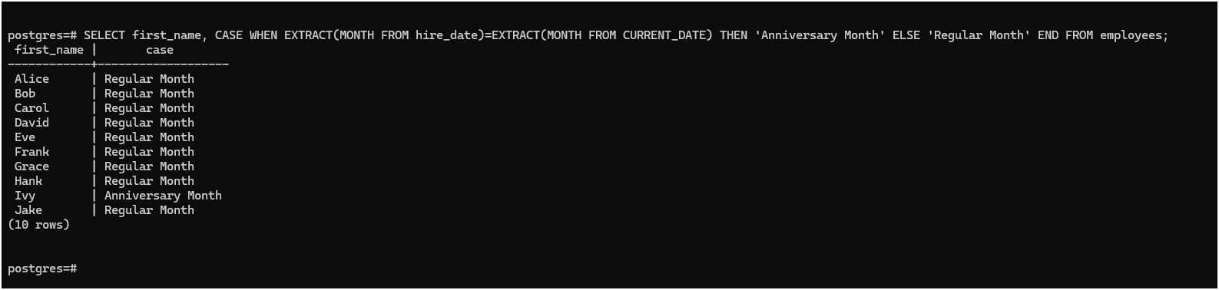

**DBMS ASSIGNMENT1.**